Course: High Performance Computing Lab

Practical No 1

PRN:22510039
Name:Shreyash Patil
Batch:B2

Title: Introduction to OpenMP

Problem Statement 1 – Demonstrate Installation and Running of OpenMP code in C
Recommended Linux based System:
Following steps are for windows:
OpenMP – Open Multi-Processing is an API that supports multi-platform shared-memory multiprocessing programming in C, C++ and Fortran on multiple OS. OpenMP uses a portable, scalable model that gives programmers a simple and flexible interface for developing parallel applications for platforms ranging from the standard desktop computer to the supercomputer.

To set up OpenMP,
We need to first install C, C++ compiler if not already done. This is possible through the MinGW Installer.
Reference: Article on GCC and G++ installer (Link)
Note: Also install `mingw32-pthreads-w32` package.

Then, to run a program in OpenMP, we have to pass a flag `-fopenmp`.
Example:
To run a basic Hello World,
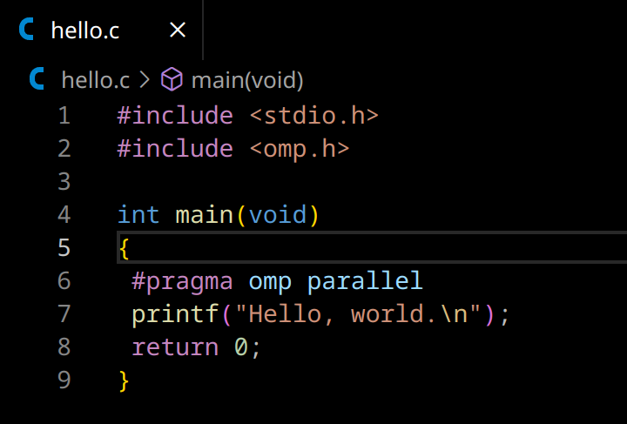
gcc -fopenmp test.c -o hello
.\hello

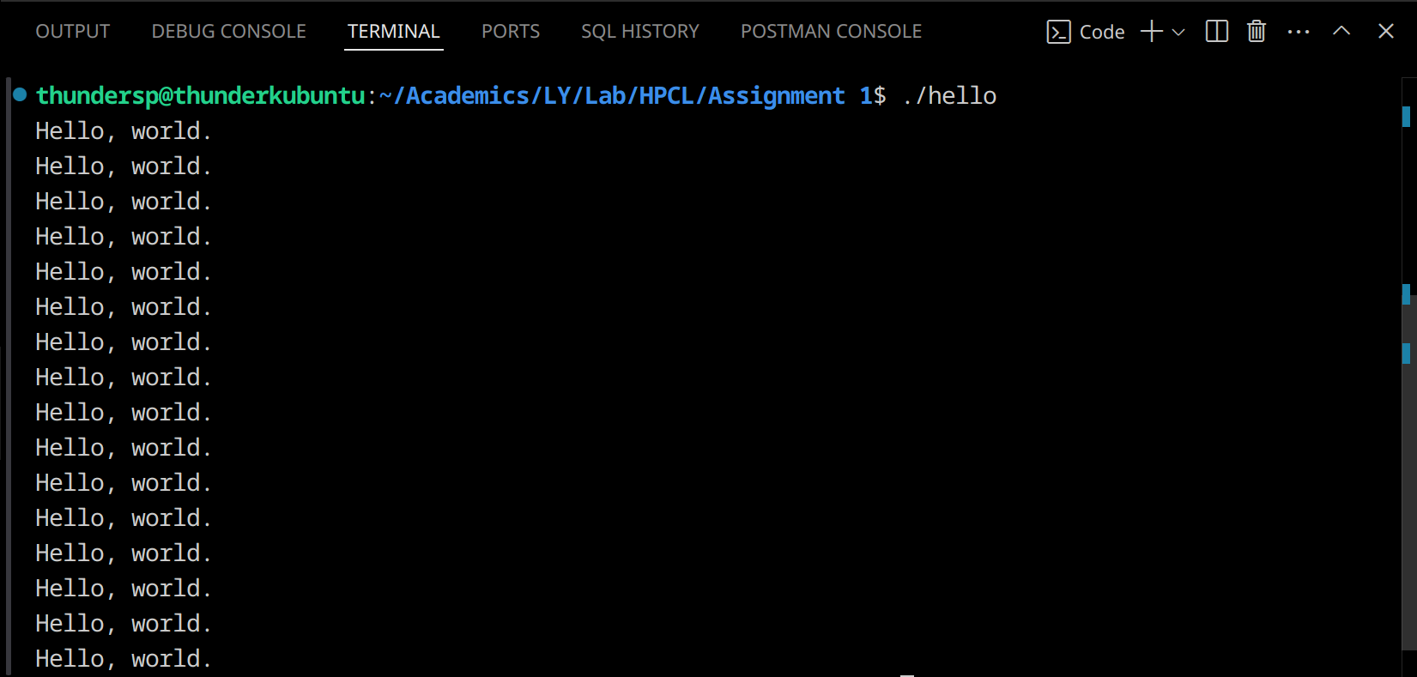
Problem Statement 2 – Print ‘Hello, World’ in Sequential and Parallel in OpenMP
We first ask the user for number of threads – OpenMP allows to set the threads at runtime. Then, we print the Hello, World in sequential – number of times of threads count and then run the code in parallel in each thread.

Code snapshot:
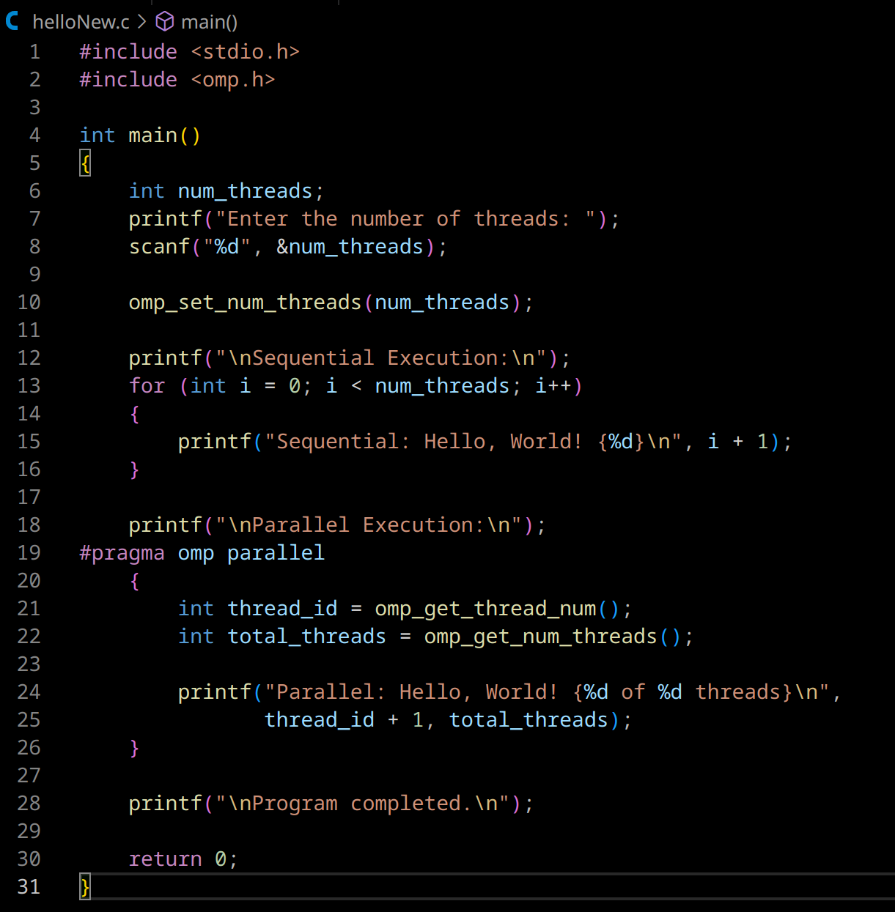

Output snapshot:
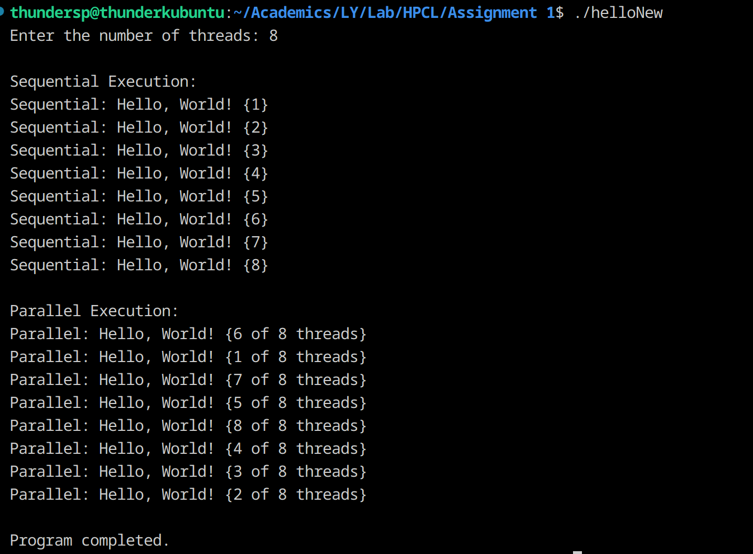
Analysis:
- In Sequential execution, the order of the iternation is predictable, it happens one after the other.
- In Parallel executtion, the print statement is executed as per the threads and when they are scheduled. Thus is execution order is not fixed.
- Sequential execution happens in O(N) whereas Parallel happens in nearly O(1) if the threads are enough.

GitHub Link: https://github.com/thundersp/hpcl

Problem statement 3: Calculate theoretical FLOPS of your system on which you are running the above codes.Elaborate the parameters and show calculation.
Ans.
Processor - Ryzen 7 5800H laptop
TheoreticalFLOPS=Number of Cores×Clock Speed (Hz)×Operations per Clock Cycle per Core
Number of cores - 8
Highest clock speed - 4.4 GHz
Operation per clock cycle per hz - 32

TheroticalFLOPS = 8 x 4.4 x 10^9 x 32
= 1.126 TFLOPS

